A ROBLOX Quest: Quest to the Guest Glitches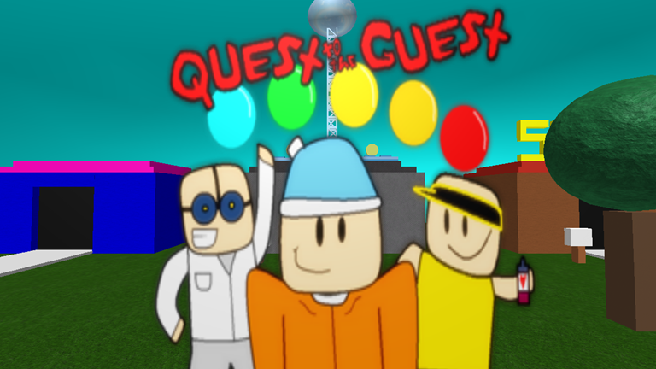
There are plenty of glitches in the game that help us get faster times.
This is the full list:
- Tele-Skip
- Return-Skip
- Spin Save
And there are a few bad glitches that you want to avoid.
This is the full list:
- Bad Warp Star
- Immovable Blocks
- Helium Hat

1. Tele-Skip
Upon receiving an orb, you are teleported back to the spawn pad unless it is the orb “Lab observate,” “Solar Radar,” or “Game Truly Completed: Savior of Roblox.” If you use a teleport door right at the time of teleporting back (about 4 seconds after touching the orb) then you will go to the door’s exit instead of the spawn pad. This trick is used 4 times in 100% and 3 times in any%.

2. Return-Skip
This is the same as Tele-Skip but applied differently. Immediately after you collect an orb that returns you to the spawn pad, press the “RETURN” button at the top left to return to the spawn pad manually. Then, do Tele-Skip with the door for Rad’s Lab. This trick saves 4 seconds, which is the waiting time for the orb to return you (which is why it has its respective name). This trick is done countless times in both any% and 100% because it can be used on most orbs that return to spawn pad and aren’t used with tele-skip.

3. Spin Save
After receiving the “Spin” power in “Super Roblox Galaxy”, you may either collect the orb or just use the “RETURN” button. Immediately when you return to the spawn pad, use your spin power. It should allow you to keep just 1 of your “Spin” powers. You may not want to attempt Return-Skip after doing spin save because it may get rid of your “Spin” power. This glitch is very useful in 100% because it allows the use of spin anywhere. Without this glitch, one of the bad glitches doesn’t have a quick solution to it.

4. Bad Warp Star
There is a warp star in “Super Roblox Galaxy” that can malfunction. This is a picture:

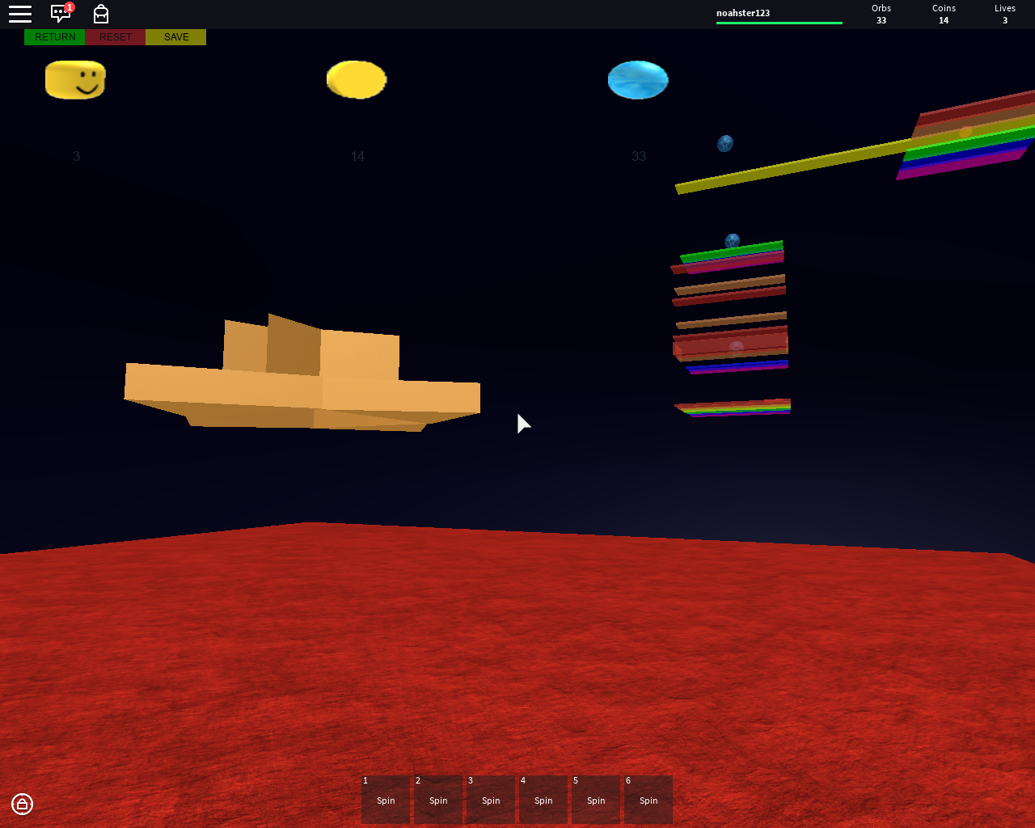
This is the last warp star in “Super Roblox Galaxy.” Sometimes it can warp you under the platform of the final area. There is not much known about this glitch. The glitch can ruin 100% runs, so you just have to hope that it doesn’t happen.

5. Immovable Blocks
In the building that stores the orb “Riddling Pyramid,” the blocks that you are supposed to push to complete the puzzle are immobile. In order to move them, you must have at least 5 hats equipped. The heavier and more hats you have, the more power you have pushing. Even with the ability to push the blocks, it takes forever to do so. In order to get the orb quickly without jumping on someone’s head, you need to perform the Spin Save glitch to be able to spin from the block to the orb.

6.Helium Hat
This glitch makes the player constantly rise upward and doesn’t let them move around to control it. This glitch has only occurred once before but the cause has been identified. The glitch occurred because of the shock wave attack of the guest. When the shock wave occurred, it knocked the player up and and back and knocked their last sword out of their hands. After that occurred, the player was floating up as described. In the Helium Hat state, all you can do is hit the “RETURN” button to go back to the spawn pad and float up from there. You can even let your friend ride you as you fly up, but be careful because it is unstable. When you fly up, you can get a bird’s eye view at all the worlds in the game as shown in this picture:
